Project Report and Documentation

Submitted By:-

Rohit Jung Karki

Submitted To:-

Mahesh Ghimire

Date: January 4, 2018

1. **Software Installation and Operating Procedures**

**Softwares and Installation**

* Platform – Java (Spring Framework with Hibernate and Spring Security)
* Structure – Maven based Multi Module Application
* Design Pattern – MVC, DAO
* IDE – Netbeans IDE version 8.0.2
* Server – Glassfish Server
* Database – Mysql

Procedure for database Exporting

* A SQL file is provided with the Project named login_system
* Create a database named login_system in PhpMyAdmin
* Export the SQL file in the database.
* Web Browser – Google Chrome (Prefered)

**Operation Procedures**

* The program is built in a multi module environment so there are two modules Core-Module and Web Module
* Do Clean and build the program and download all Dependencies

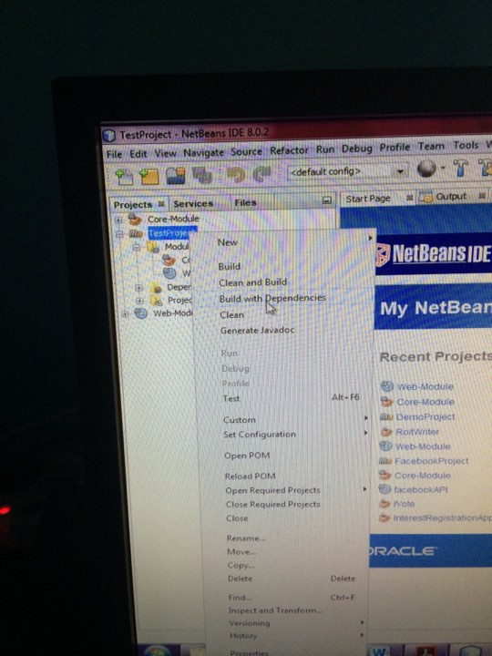

* Deploy the Web-Module to run the Application

1. **Database Structure**

PK

|  |
| --- |
| tbl_users |
| user_id |
| First_name |
| last_name |
| email |
| contact_no |
| username |
| password |
| role |
| added_date |
| modified_date |
| created_by |
| status |

|  |
| --- |
| tbl_assignedTo |
| assigned_id |
| created_by |
| user_id |

|  |
| --- |
| tbl_admins |
| admin_id |
| First_name |
| last_name |
| email |
| contact_no |
| username |
| password |
| role |
| added_date |
| modified_date |
| created_by |
| status |

|  |
| --- |
| tbl_assignedAdmin |
| assigned_id |
| created_by |
| admin_id |

|  |
| --- |
| tbl_super_admin |
| super_admin_id |
| First_name |
| last_name |
| email |
| contact_no |
| username |
| password |
| role |
| added_date |
| modified_date |
| created_by |
| status |

PK

PK

PK

PK

1. **Login Information**

**This section contains all the information about different User types and their username and password.**

* **Super Admin**

|  |  |
| --- | --- |
| Username | Password |
| super_admin | 123456 |
| super_admin1 | 123456 |
| super_admin2 | 123456 |

* **Admin**

|  |  |
| --- | --- |
| Username | Password |
| admin | 123456 |
| john_admin | 123456 |
| hope | 123456 |
| admin_madhav | 123456 |
| admin_manish | 123456 |

* **Users**

|  |  |
| --- | --- |
| Username | Password |
| ram | 123456 |
| hari | 123456 |
| User | 123456 |
| gopal | 123456 |
| kedar | 123456 |
| Bishal | 123456 |
| johnny | 123456 |
| harish | 123456 |
| trishna | 123456 |
| sita | 123456 |